1.21 Downloading and uploading data
Today, I integrated spreadsheet as a database into the points management system and implemented the functions of uploading and downloading data (Students and Events). The newly added section can be divided into two sub-modules: upload and download.
Basic idea: A spreadsheet is used as the database, and the URL of the Apps Script Web App is used as a pipeline to connect the database and the web app. The two interact through a series of agreed-upon actions.
Downloading module:
All data downloads are done during the program's initialization phase:
renderall() $→$ Download data from database $→$ re-render the UI
The program sends two requests to the database via fetch() to retrieve student information and points event (action=students/events). The spreadsheet receives the request and responds according to the action: returning all content from the student and event tabs in the spreadsheet.
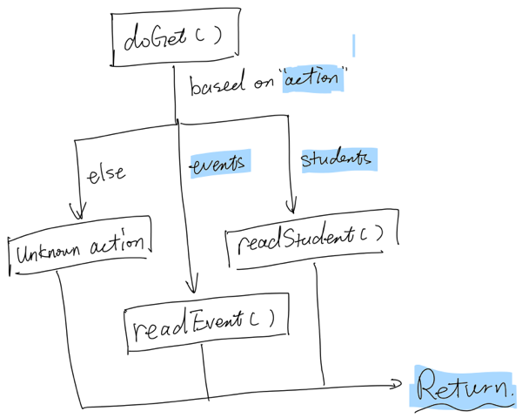

After receiving the content returned by the spreadsheet, the program organizes it into students and events arrays. Then, it recalculates the student scores based on the events array and re-renders the entire web app.
Uploading module:
The uploading module can be divided into two sub-parts: appendEvent() and updateEvent(). The principle is similar: send request to the spreadsheet, and in doPost(), distribute the operation based on the action.
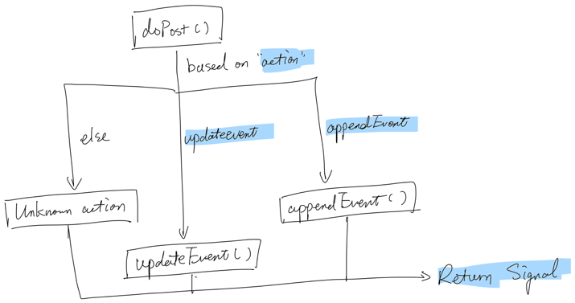

appendEvent()
This part is triggered at the end of submitEvent(). It uses fetch() to send a package to the spreadsheet containing action = appendEvent, and the newly assembled point event. Once the spreadsheet receives this, it will append it directly to the event tab.
updateEvent()
This part is triggered after the points event is modified (openEditPrompt()). A package is sent to the spreadsheet containing the action = updateEvent and information about the point event that was modified. After receiving this, the spreadsheet will iterate through all events, find the corresponding event based on the event_id, and update the information.
Compared to other method:
This approach, which uses a spreadsheet as a database, has its own advantages and disadvantages compared to other approaches:
Approaches | Description | Strengths | Limitations
Approach A | Google Sheets  Apps Script Web App (HTTP API) | - Quick to learn, low cost, and simple deployment  - Highly auditable (very friendly to school scenarios)  - Friendly for non-engineering personnel | - Performance and scalability  - security issues  - low constraints require self-maintenance of format.
Approach B | Firebase  Firebase Auth | - A true cloud database, offering significantly better scalability and performance than Sheets.  - It comes with a built-in user system and security rules. Frontend integration is very mature (JS SDK).  - It has high learning value as a "legitimate cloud database". | - I need to learn document models/query methods/permission rules.  - For complex transactions or auditing/login consistency, a more rigorous design is required

I choose to use this approach because it is more suitable for MVP. For future further development, I could change the database from spreadsheet to Firebase.

